The Turing machine M has:
- States q and p; q is the start state
- Tape symbols 0, 1 and B; 0 and 1 are inputs symbols, and B is the blank.
- The following next-move function:
State | Tape Symbol | Move
q | 0 | (q, 0, R)
q | 1 | (p, 0, R)
q | B | (q, B, R)
p | 0 | (q, 0, L)
p | 1 | None (halt)
p | B | (q, 0, L)

TURING MACHINE DIAGRAM:
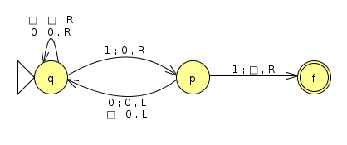Turing machine

SIMULATION RESULT:
String: 1010110
q1010110 ⊢ 0p010110 ⊢ q0010110 ⊢ 0q010110 ⊢ 00q10110 ⊢ 000p0110 ⊢ 00q00110 ⊢ 000q0110 ⊢ 0000q110 ⊢ 00000p10 ⊢ halt

